**About Us**

Tiranga Aerospace is a proud Indian defense and aerospace startup driven by innovation, integrity, and a deep commitment to nation-building. Registered under MSME, we focus on indigenous development and manufacturing of advanced technologies in SATCOM, radar systems, RF solutions, and high-performance antennas, delivering mission-critical systems tailored to the needs of our armed forces and strategic sectors.

With a leadership team comprising renowned scientists, retired defense experts, and dynamic professionals from organizations like ISRO, BEL, BHEL, HAL, and other premier institutions, Tiranga Aerospace brings together decades of experience and fresh innovation to serve India’s defense ecosystem. We operate with a clear vision—to empower India through technological self-reliance, in line with the *Make in India* and *Aatmanirbhar Bharat* initiatives.

We have also forged strategic international collaborations, ensuring that state-of-the-art global technologies are localized, manufactured, and supplied exclusively through Tiranga Aerospace, fully compliant with Indian defense regulations.

Areas of Expertise

* **Defense & Aerospace Systems**
* Information Technology (IT)
* Research, Design & Development
* Sales & Marketing
* Skill Development & Industry Training
* Manpower Solutions

📊 Market Analysis (Karnataka - 5 Year Average)

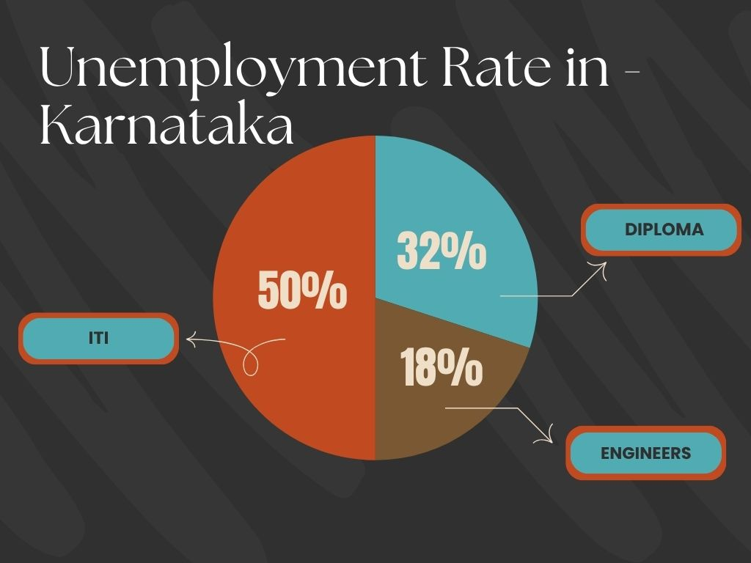

### 🎯 ****Our Aim****

"To empower students and professionals through industry-aligned skill development, unlocking their full potential and transforming them into future-ready talent."

### 🏆 ****Our Goal****

"To bridge the gap between education and employment by aligning individuals with their core domain, reducing skill mismatch, and ensuring purposeful, fulfilling careers."

### 🔧 ****Tiranga’s Skilled Manpower Program****

At **Tiranga Aerospace**, we take pride in nurturing a robust pool of industry-ready talent across three key categories:

1. **Engineering Graduates**
2. **Diploma Holders (Technical Streams)**
3. **ITI Technicians**

### 📚 ****Foundational Training – 3 Months Intensive Program****

Each selected candidate undergoes a **rigorous 3-month training program** at our facility, meticulously designed to align with current industrial demands in the **SATCOM, Antenna, RF, and Radar domains**.

This program is carefully crafted to:

* Build **fundamental technical knowledge** through real-world applications.
* Provide **hands-on exposure** to critical tools, equipment, and simulation environments.
* Introduce **domain-specific projects** and micro-task modules to accelerate skill development.

### 🧠 ****Beyond Technical Skills****

At Tiranga, we believe that **discipline, professionalism, and character** are just as vital as technical competence. Hence, we:

* Encourage **personal development**, communication skills, and time management.
* Promote **team collaboration**, adaptability, and ethical work culture.
* Conduct regular sessions on **interview readiness**, workplace etiquette, and presentation skills.

### 🚀 ****Outcome-Focused Training****

Our objective is not just to train, but to **transform raw talent into employable, confident, and job-ready professionals**. With this holistic development model:

* Many of our trainees secure **core domain placements**.
* Industry feedback has consistently highlighted our candidates' **practical knowledge, discipline, and learning agility**.

They will emerge as fully industry-ready professionals & contribute effectively from day one.

### 🌟 ****Why Partner With Us?****

Whether you're a student, a parent, or an employer:

* **Students** gain career clarity and job-oriented skills.
* **Employers** receive pre-trained candidates who adapt faster and contribute earlier.
* **Institutions** benefit by enhancing their placement track record.

### ****Why Choose Tiranga Aerospace?****

At **Tiranga Aerospace**, we go beyond traditional recruitment.  
We are on a mission to **reshape the employment ecosystem** by supplying the industry with **skilled, trained, and industry-ready talent**.

We don’t just match people with jobs —  
we **align passion with purpose** and **skills with opportunity**, ensuring a win-win for both candidates and employers.

### 🌟 What Sets Us Apart:

* ✅ **Skill-Based Deployment** — Our candidates undergo focused technical training to meet the Industrial standards, which make them an “Industrial Ready” candidate.
* ✅ **Holistic Development** — We nurture not only technical proficiency but also **discipline, professionalism, and personality**.
* ✅ **Industry Integration** — We maintain strong ties with the **defense, telecom, and core engineering sectors**, ensuring relevant placement opportunities.
* ✅ **Inclusive Approach** — We support **Engineers, Diploma holders, and ITI technicians**, helping bridge the skill gap across all levels of technical manpower.
* ✅ **Right Job for the Right Candidate**
* ✅ **Skill-Focused Training**
* ✅ **Practical, Hands-On Learning**
* ✅ **Commitment to Quality & Excellence**

### ****Our Strategic Talent Solutions****

* 🔍 **Targeted Talent Acquisition**  
  Precision hiring that aligns with your specific technical and cultural requirements.
* ⚡ **Accelerated Onboarding & Deployment**  
  Fast-track hiring processes that deliver qualified candidates ready to contribute from Day One.
* 🔁 **Guaranteed Replacement Assurance**  
  We ensure performance-based continuity with a dependable replacement policy.
* 🔄 **Full-Cycle Backfill & Continuity Support**  
  End-to-end coverage for attrition, ensuring uninterrupted business operations.
* 🎓 **Campus Engagement & Employer Branding**  
  Build your brand across campuses with customized outreach, workshops, and recruitment drives.

## 🔚 **Let’s Build the Future Together**

At **Tiranga Aerospace**, we don’t just train manpower —  
**we craft future-ready professionals** who are aligned with industry demands, committed to excellence, and ready to contribute from day one.

With our **deep domain expertise**, **industry-integrated training programs**, and **mission-driven approach**, we are uniquely positioned to become your **trusted partner in skilled workforce development**.

Whether you’re an employer looking for pre-trained, high-performance candidates or an institution aiming to elevate your placement success —  
**we invite you to collaborate with Tiranga Aerospace and co-create a self-reliant, skilled India.**

### 📞 ****Contact Us****

**Tiranga Aerospace**  
📍 2nd floor, Hillside Meadows Layout, Adityanagar, Vidyaranyapura, Bengaluru, Karnataka 560097  
📧 hr@tirangaaerospace.com  
📞 9035054448/7204939063  
🌐 <https://www.tirangaaerospace.com/>